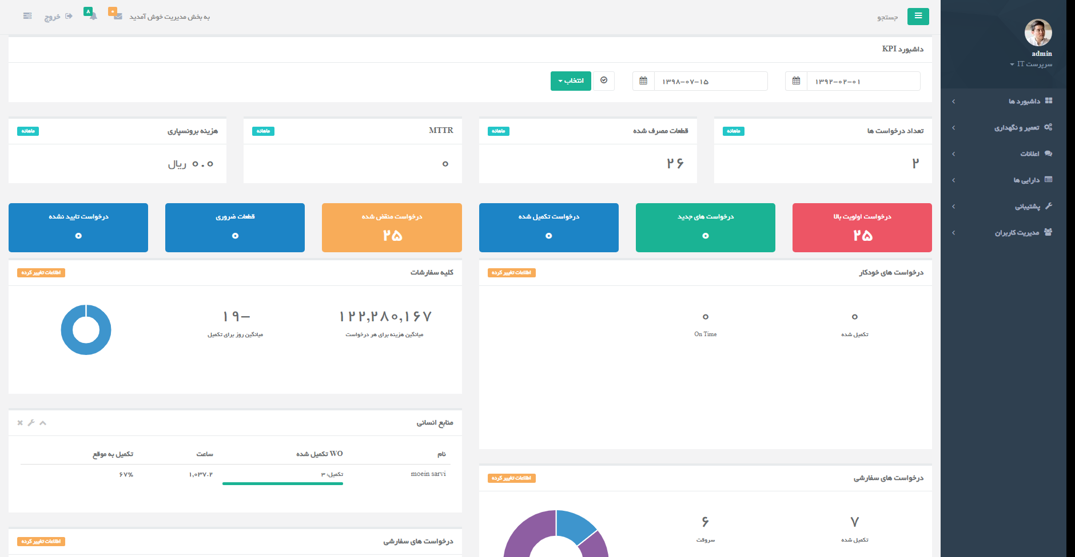

تعداد درخواست ها:

Template: cmms/summery/worequeted.html

Js file:Info.js

Js method:GetWoReqNum

url: 'Summery/'+$("#dashboardt1").val()+'/'+$("#dashboardt2").val()+'/GetWoReqNum/',

view:dashboardview.py

view Method: GetWoReqNum(request,startHijri,endHijri)

WOUtility.getWoReqNum(start,end)

قطعات مصرف شده

Template: cmms/summery/ wopart.html

Js file:Info.js

Js method: GetWoPartNum

url: 'Summery/'+$("#dashboardt1").val()+'/'+$("#dashboardt2").val()+'/GetWoPartNum/',

view:dashboardview.py

view Method: GetWoPartNum (request,startHijri,endHijri)

PartUtility.getUsedPartNum(start,end)

MTTR

Template: cmms/summery/ mttr.html

Js file:Info.js

Js method: GetMTTR

url: 'Summery/'+$("#dashboardt1").val()+'/'+$("#dashboardt2").val()+'/GetMTTR/',

view Method: GetMTTR(request,startHijri,endHijri

MTTR.getMTTR(start,end)

هزینه برونسپاری

Template: cmms/summery/ misc.html

Js file:Info.js

Js method: GetMisc

url: 'Summery/'+$("#dashboardt1").val()+'/'+$("#dashboardt2").val()+'/GetMiscCost/',

view Method: GetMiscCost (request,startHijri,endHijri

ExtraCost.getMiscCost(start,end)

درخواست اولویت بالا

Template: cmms/summery/ highprioritywo.html

Sub Template: cmms/summery/ partialhighprioritywo.html

Js file:inside highprioritywo

Js method: GetHighPriorityWO

url: 'Summery/'+$("#dashboardt1").val()+'/'+$("#dashboardt2").val()+'/GetMiscCost/',

view Method: GetMiscCost (request,startHijri,endHijri

ExtraCost.getMiscCost(start,end)